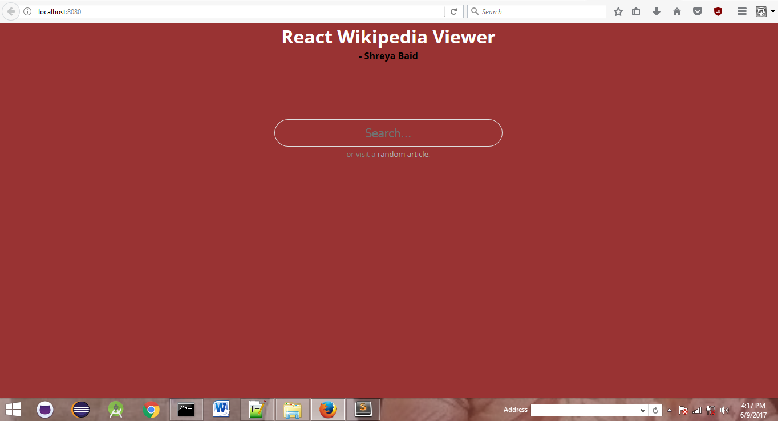

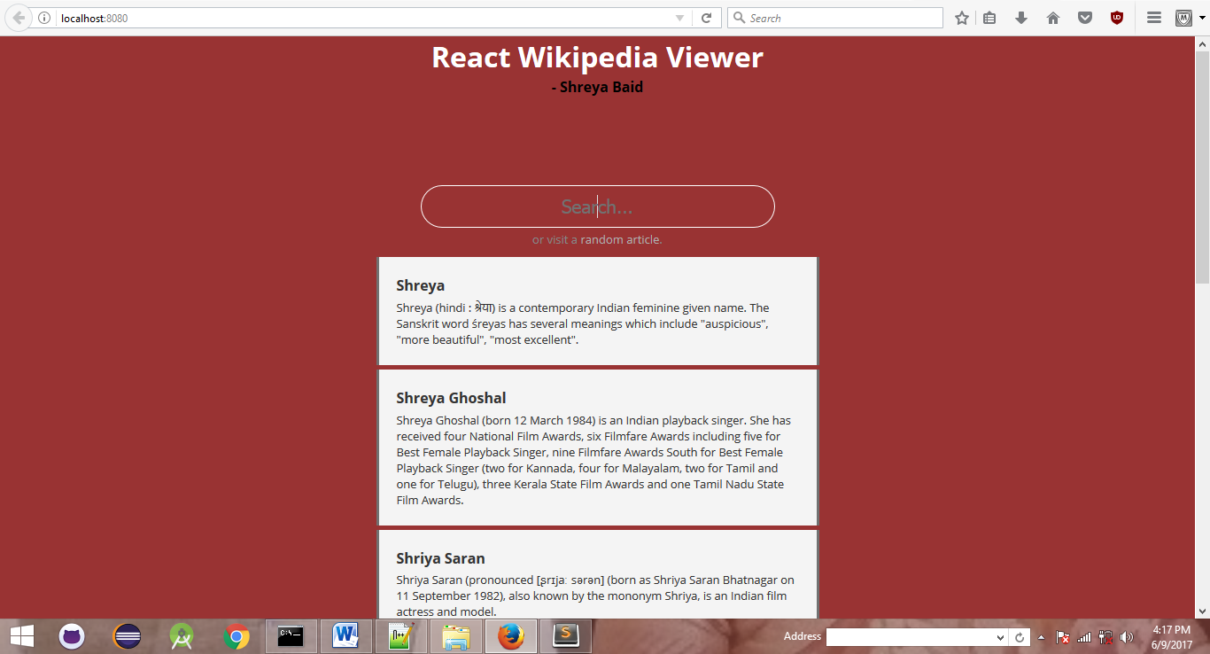

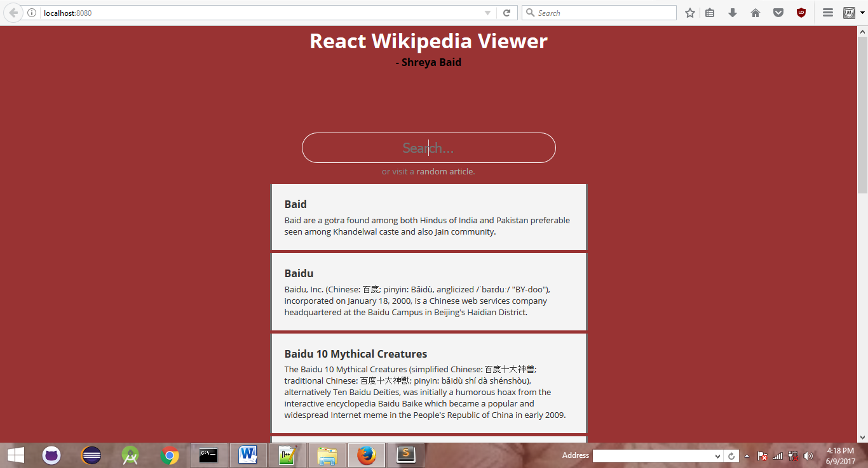

1. npm install
2. npm install webpack webpack-dev-sever –save-dev
3. npm install react react-dom –save
4. npm install babel-core babel-loader babel-preset-es2015 babel-preset-react –save-dev
5. npm run it